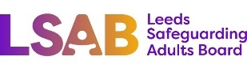 | Risk Assessment & Management Meeting | 

Agenda
- Welcome and introductions

- Purpose of meeting:

- To share information
- To understand the nature of the concerns
- To assess risk
- To work towards achieving the person’s wishes and desired outcomes
- To plan how to respond as a partnership

- Confidentiality Agreement:

All information shared at this meeting is strictly confidential. It should not be used for any purpose other than the safeguarding or care of the person concerned.

- Information about the person at risk
- Including decision-making capacity and need for representation
- Why is this assessment needed?
- Views of the person at risk (and/or their representative) about the concerns
- Desired outcomes: Changes the person at risk wants to be achieved
- What are the risks of harm being assessed? What is the evidence?
- What is the potential harm and for whom?
- What existing factors increase & decrease the risk of harm?
- Risk Management Plan actions
- Contingency Plan
- What are the views of the person at risk of these plans? Do they feel safer?
- Views of relevant people on these plans, including views of relatives
- Arrangements for review

